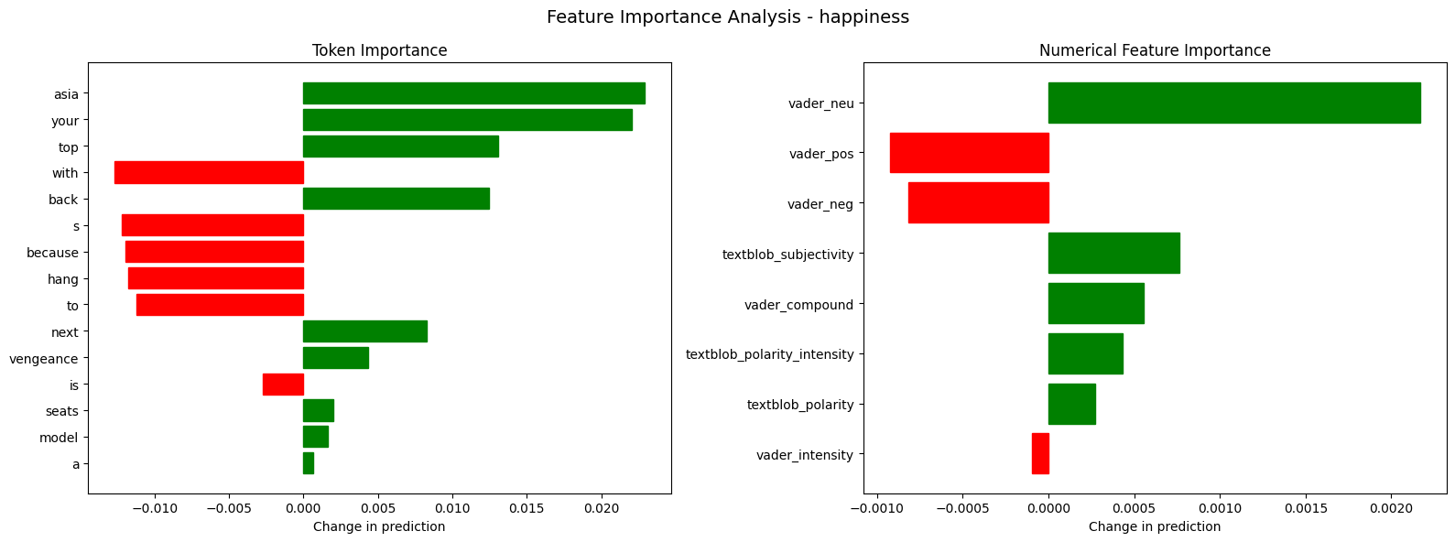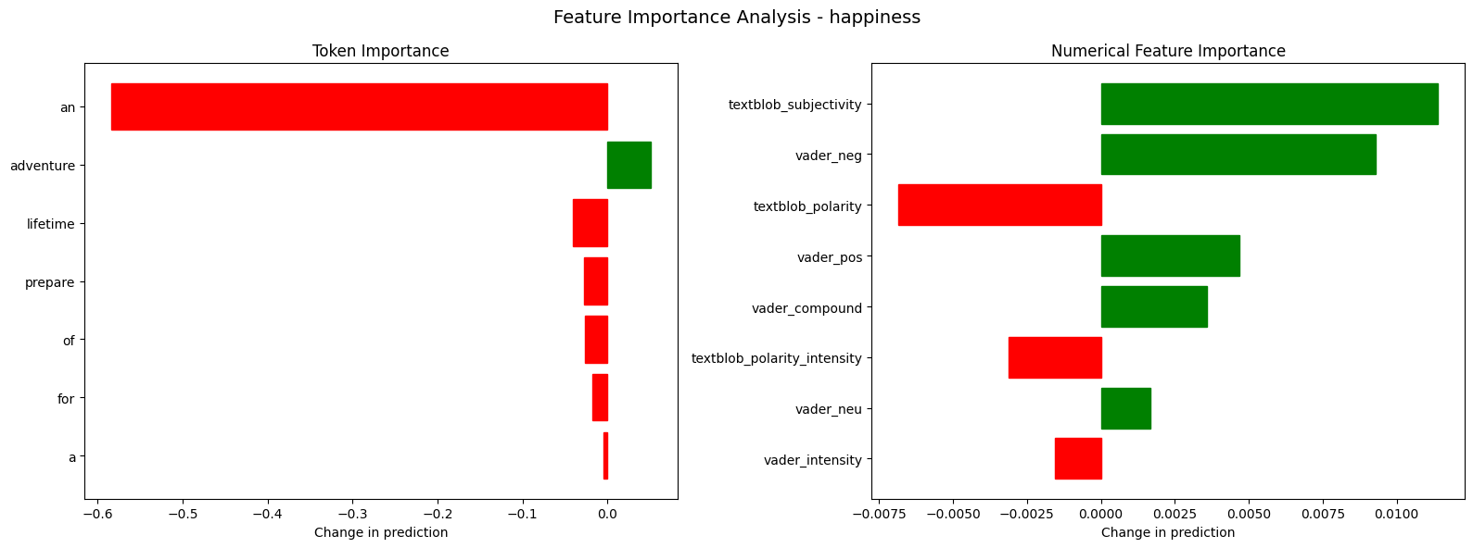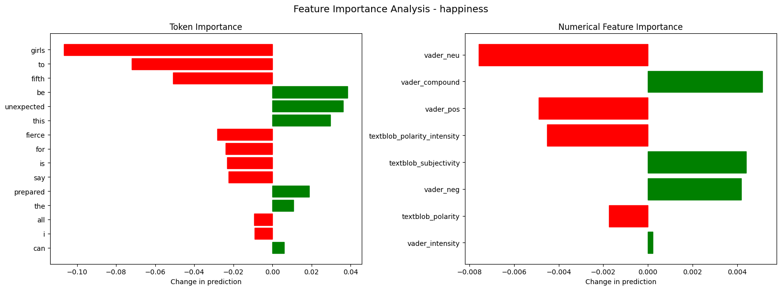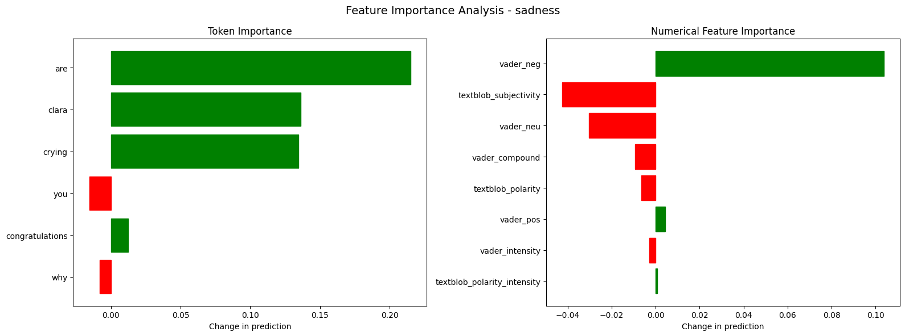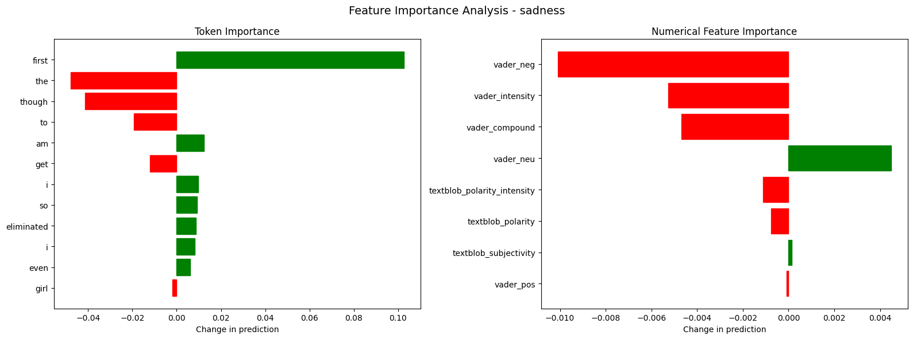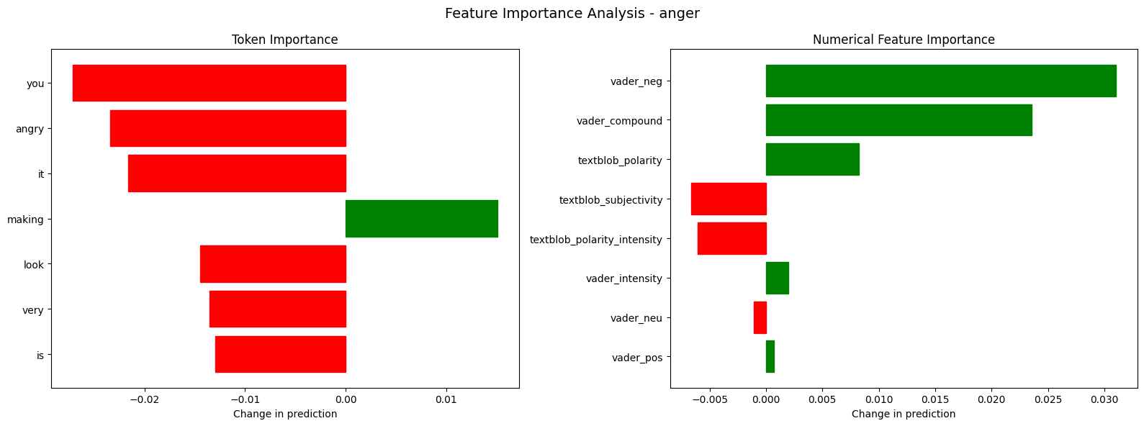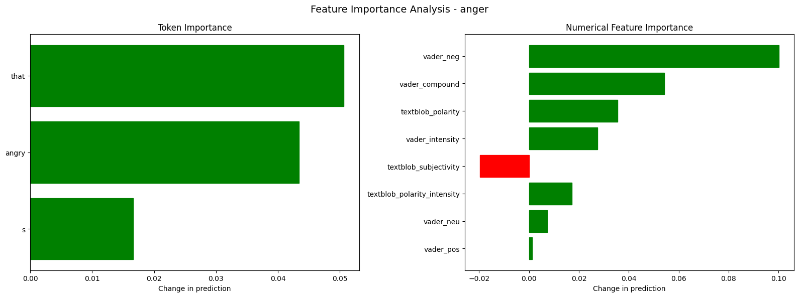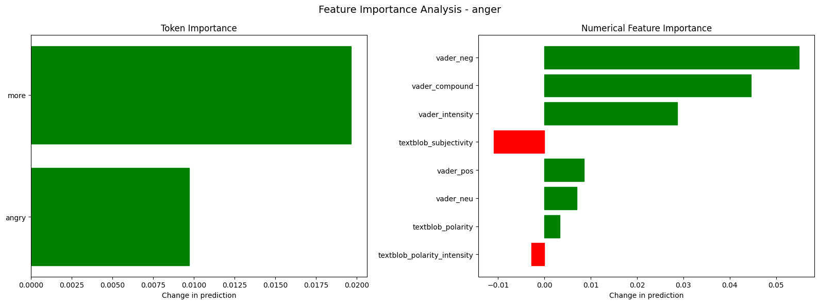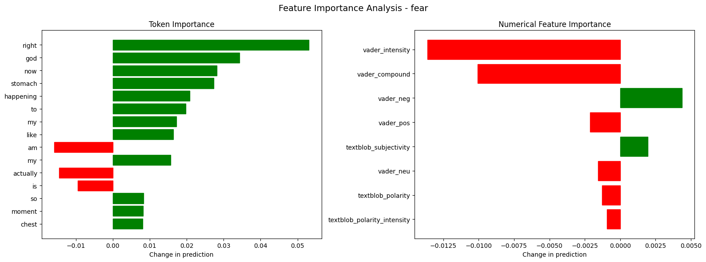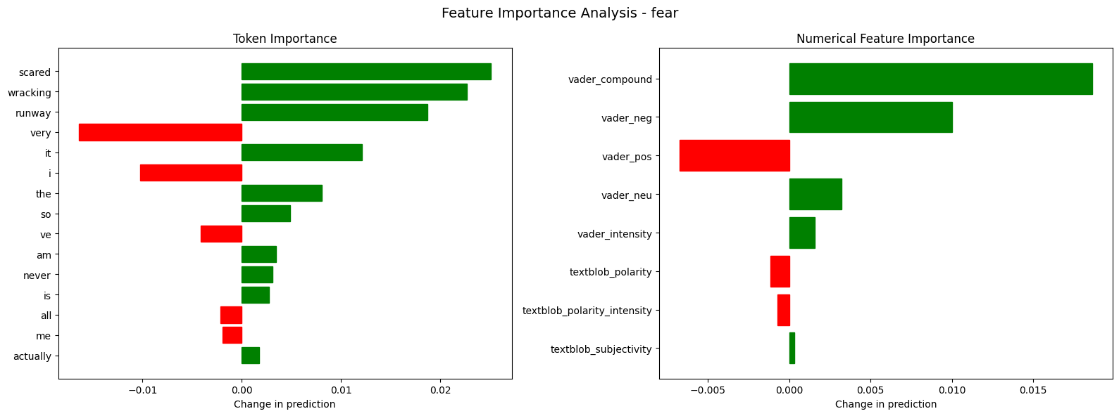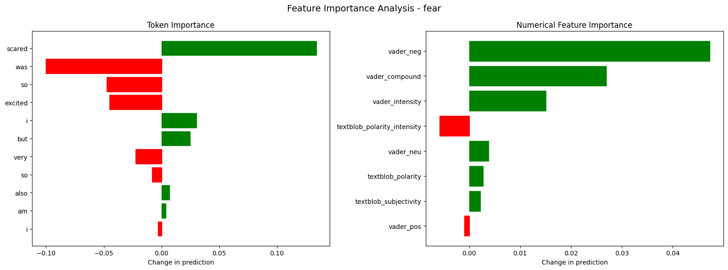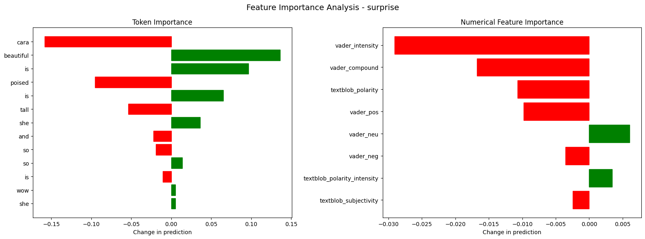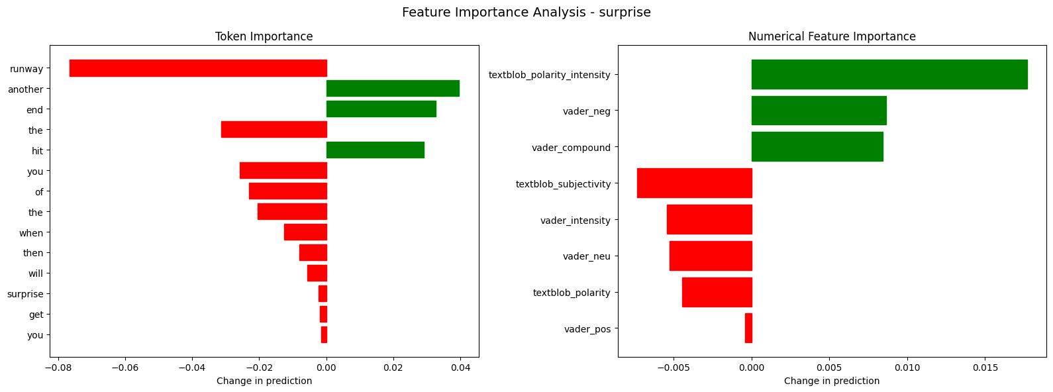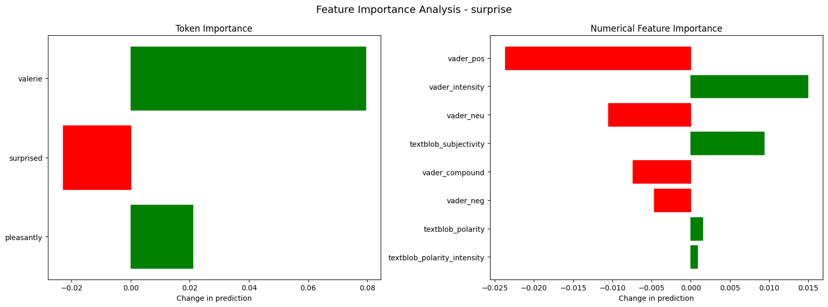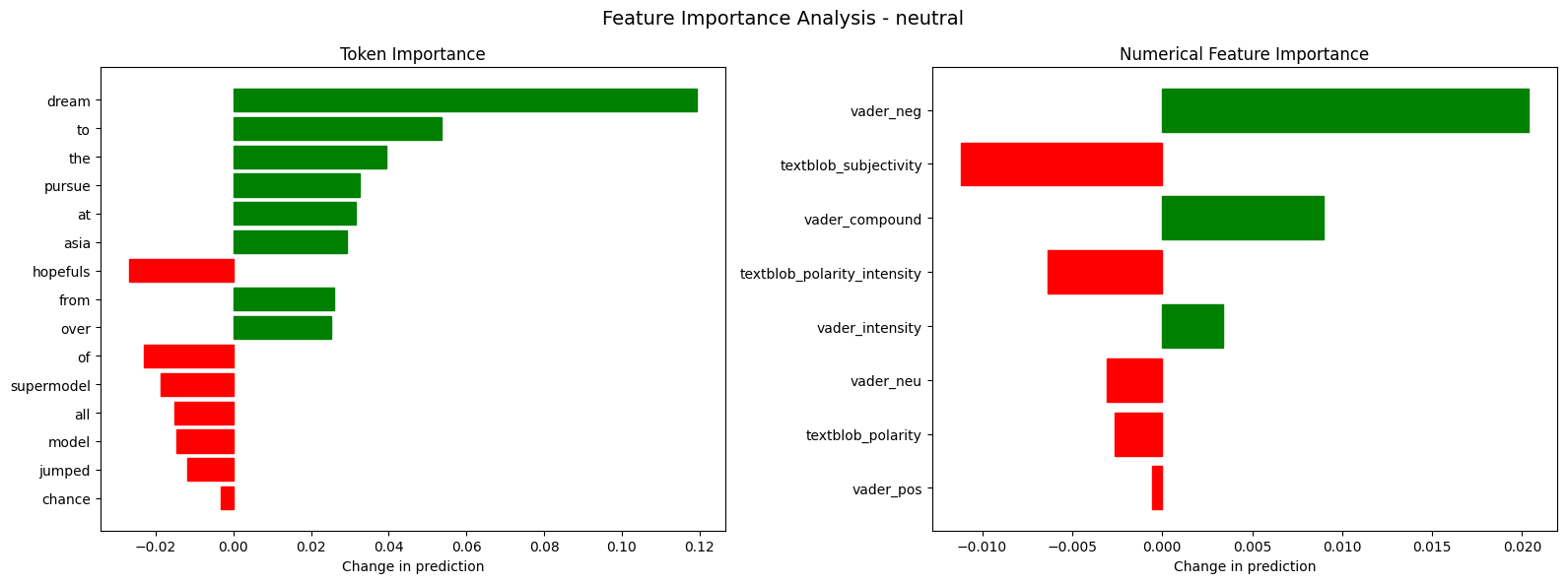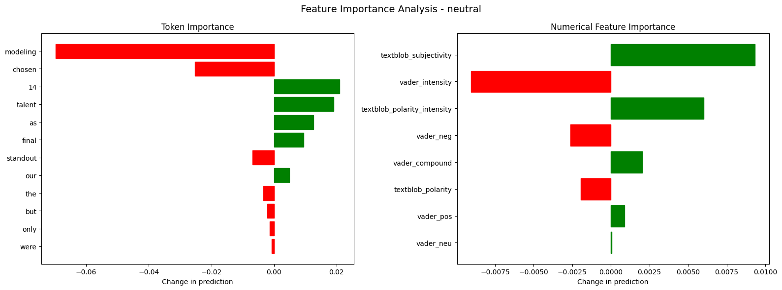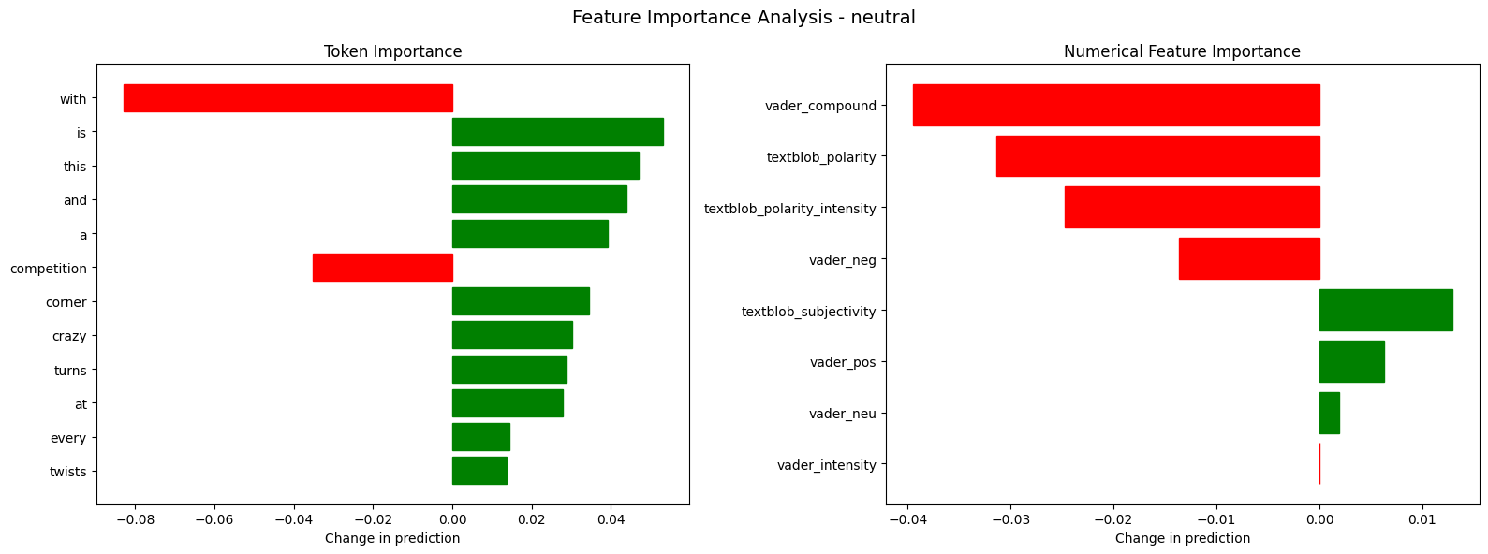
Most important tokens by emotion:

HAPPINESS:
- an: -0.583917
- girls: -0.106588
- fifth: -0.050873
- adventure: 0.050443
- lifetime: -0.040269
- be: 0.038506
- unexpected: 0.036187
- this: 0.029725
- fierce: -0.028159
- prepare: -0.027373

SADNESS:
- are: 0.215039
- clara: 0.136227
- crying: 0.134385
- first: 0.102606
- the: -0.047959
- though: -0.041412
- to: -0.019361
- you: -0.015511
- congratulations: 0.012530
- am: 0.012291

ANGER:
- that: 0.050613
- you: -0.027134
- angry: -0.023425
- it: -0.021636
- more: 0.019646
- s: 0.016625
- making: 0.015106
- look: -0.014454
- very: -0.013557
- is: -0.012982

FEAR:
- was: -0.100210
- right: 0.053046
- excited: -0.045240
- god: 0.034279
- now: 0.028188
- stomach: 0.027384
- scared: 0.025106
- but: 0.024821
- wracking: 0.022663
- happening: 0.020810

SURPRISE:
- cara: -0.158145
- beautiful: 0.136129
- is: 0.096366
- poised: -0.095312
- valerie: 0.079440
- runway: -0.076572
- tall: -0.053691
- another: 0.039688
- she: 0.036162
- end: 0.032739

NEUTRAL:
- dream: 0.119373
- with: -0.083015
- modeling: -0.069712
- to: 0.053478
- is: 0.053040
- this: 0.046882
- and: 0.043857
- the: 0.039396
- a: 0.039210
- competition: -0.035197

Most important numerical features by emotion:

HAPPINESS:
- textblob_subjectivity: 0.005521
- vader_neg: 0.004217
- vader_compound: 0.003096

SADNESS:
- vader_neg: 0.046824
- textblob_subjectivity: -0.021149
- vader_neu: -0.012880

ANGER:
- vader_neg: 0.062070
- vader_compound: 0.040766
- vader_intensity: 0.019340

FEAR:
- vader_neg: 0.020567
- vader_compound: 0.011837
- vader_pos: -0.003297

SURPRISE:
- vader_pos: -0.011288
- textblob_polarity_intensity: 0.007315
- vader_intensity: -0.006540

NEUTRAL:
- textblob_polarity: -0.011989
- vader_compound: -0.009498
- textblob_polarity_intensity: -0.008365

Example 1:
Text: hang on to your seats because asia s next top model is back with a vengeance
True emotion: happiness
Predicted emotion: neutral
Most important tokens:
- asia: 0.022934
- your: 0.022053
- top: 0.013058
- with: -0.012679
- back: 0.012441

--------------------------------------------------

Example 2:
Text: prepare for an adventure of a lifetime
True emotion: happiness
Predicted emotion: anger
Most important tokens:
- an: -0.583917
- adventure: 0.050443
- lifetime: -0.040269
- prepare: -0.027373
- of: -0.026552

--------------------------------------------------

Example 3:
Text: all i can say girls for this fierce fifth season is be prepared to expect the unexpected
True emotion: happiness
Predicted emotion: surprise
Most important tokens:
- girls: -0.106588
- to: -0.071910
- fifth: -0.050873
- be: 0.038506
- unexpected: 0.036187

--------------------------------------------------

Example 4:
Text: congratulations clara why are you crying
True emotion: sadness
Predicted emotion: sadness
Most important tokens:
- are: 0.215039
- clara: 0.136227
- crying: 0.134385
- you: -0.015511
- congratulations: 0.012530

--------------------------------------------------

Example 5:
Text: so even though i am the first girl to get eliminated i
True emotion: sadness
Predicted emotion: neutral
Most important tokens:
- first: 0.102606
- the: -0.047959
- though: -0.041412
- to: -0.019361
- am: 0.012291

--------------------------------------------------

Example 6:
Text: it is making you look very angry
True emotion: anger
Predicted emotion: neutral
Most important tokens:
- you: -0.027134
- angry: -0.023425
- it: -0.021636
- making: 0.015106
- look: -0.014454

--------------------------------------------------

Example 7:
Text: that s angry
True emotion: anger
Predicted emotion: surprise
Most important tokens:
- that: 0.050613
- angry: 0.043373
- s: 0.016625

--------------------------------------------------

Example 8:
Text: more angry
True emotion: anger
Predicted emotion: neutral
Most important tokens:
- more: 0.019646
- angry: 0.009731

--------------------------------------------------

Example 9:
Text: at this moment i am feeling like my stomach is up to my chest like so nervous oh my god it is actually happening right now
True emotion: fear
Predicted emotion: neutral
Most important tokens:
- right: 0.053046
- god: 0.034279
- now: 0.028188
- stomach: 0.027384
- happening: 0.020810

--------------------------------------------------

Example 10:
Text: all right i am scared i ve never actually been on the runway so it is very nerve wracking for me
True emotion: fear
Predicted emotion: anger
Most important tokens:
- scared: 0.025106
- wracking: 0.022663
- runway: 0.018700
- very: -0.016414
- it: 0.012101

--------------------------------------------------

Example 11:
Text: so i am very excited but i was so scared also
True emotion: fear
Predicted emotion: fear
Most important tokens:
- scared: 0.134108
- was: -0.100210
- so: -0.047253
- excited: -0.045240
- i: 0.030465

--------------------------------------------------

Example 12:
Text: wow cara is so beautiful she is tall and she is so poised
True emotion: surprise
Predicted emotion: neutral
Most important tokens:
- cara: -0.158145
- beautiful: 0.136129
- is: 0.096366
- poised: -0.095312
- is: 0.064886

--------------------------------------------------

Example 13:
Text: then when you hit the end of the runway you will get another surprise
True emotion: surprise
Predicted emotion: anger
Most important tokens:
- runway: -0.076572
- another: 0.039688
- end: 0.032739
- the: -0.031303
- hit: 0.029146

--------------------------------------------------

Example 14:
Text: pleasantly surprised valerie
True emotion: surprise
Predicted emotion: neutral
Most important tokens:
- valerie: 0.079440
- surprised: -0.022926
- pleasantly: 0.021010

--------------------------------------------------

Example 15:
Text: thousands of model hopefuls from all over asia jumped at the chance to pursue their supermodel dream
True emotion: neutral
Predicted emotion: neutral
Most important tokens:
- dream: 0.119373
- to: 0.053478
- the: 0.039396
- pursue: 0.032489
- at: 0.031393

--------------------------------------------------

Example 16:
Text: but only the standout modeling talent were chosen as our final 14
True emotion: neutral
Predicted emotion: surprise
Most important tokens:
- modeling: -0.069712
- chosen: -0.025270
- 14: 0.020950
- talent: 0.019065
- as: 0.012646

--------------------------------------------------

Example 17:
Text: with twists and turns at every corner this is a crazy competition
True emotion: neutral
Predicted emotion: surprise
Most important tokens:
- with: -0.083015
- is: 0.053040
- this: 0.046882
- and: 0.043857
- a: 0.039210

--------------------------------------------------

